1. **Create VM**

* **Login to azure portal with plural sight email and password**
* **Access the site** <https://portal.azure.com/#create/Microsoft.Template>

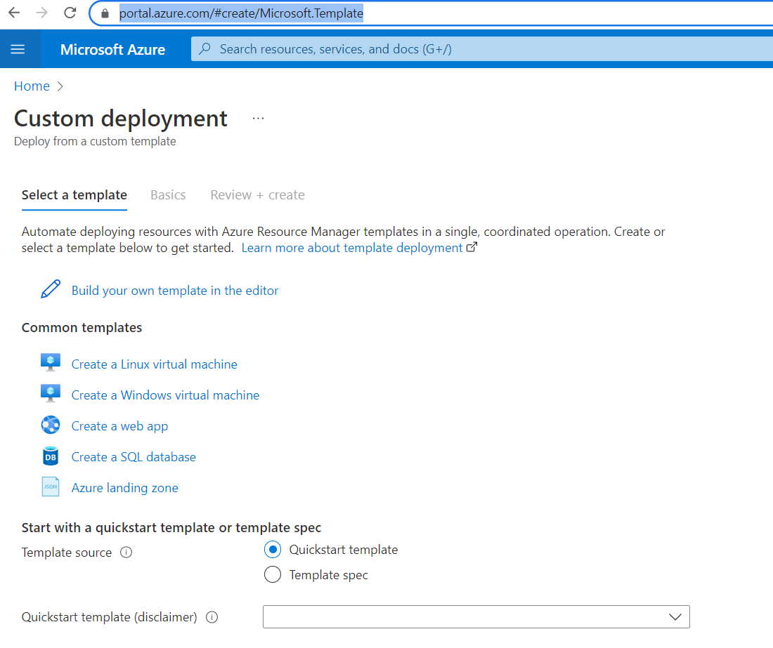

* **Select the "create a linux virtual machine "option**

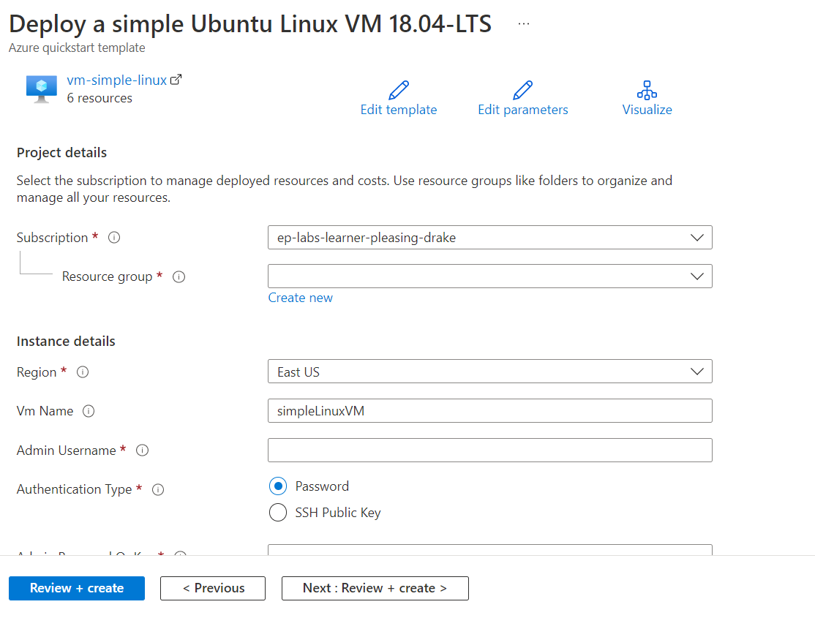

* **Provide Resource Group ,username ,password and click Review+Create option**
* **Once validation Passed , click create button**
* **Linux VM will be created .**
* **Once the deployment is completed , go to the resource .**

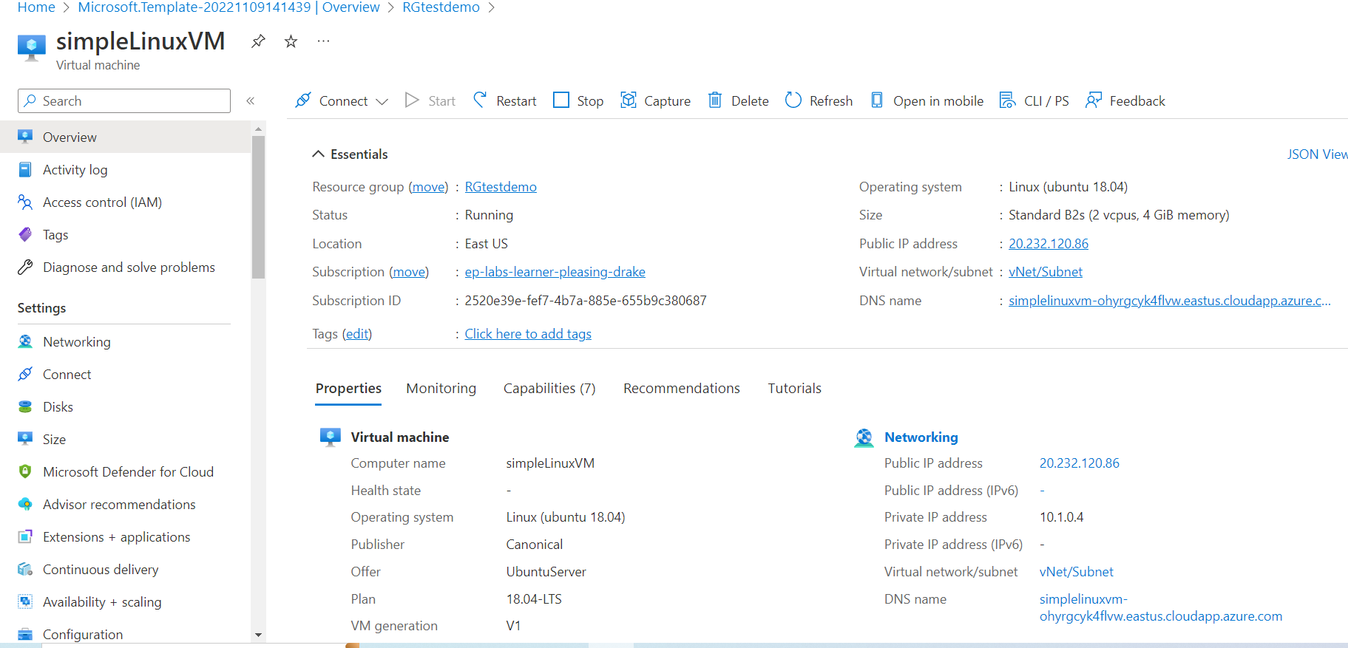

* **Click on Azure CLI**
* **use command to connect to VM**

ssh username@VM-ip

* **Provide VM password**

1. **Creating Azure Database for MySQL single server**

* **Command to create DB using CLI .Change the username and password**

az mysql server create --resource-group myresourcegroup --name mydemoserver1 --location westus --admin-user myadmin --admin-password password --sku-name GP_Gen5_2 --version 5.7

* **Using Template** Login to azure portal , check the site <https://portal.azure.com/#create/Microsoft.Template>, go to select a template , in quick start template type “quickstarts/microsoft.dbforpostgresql/managed-postgresql-with-vnet/”   and select the template .

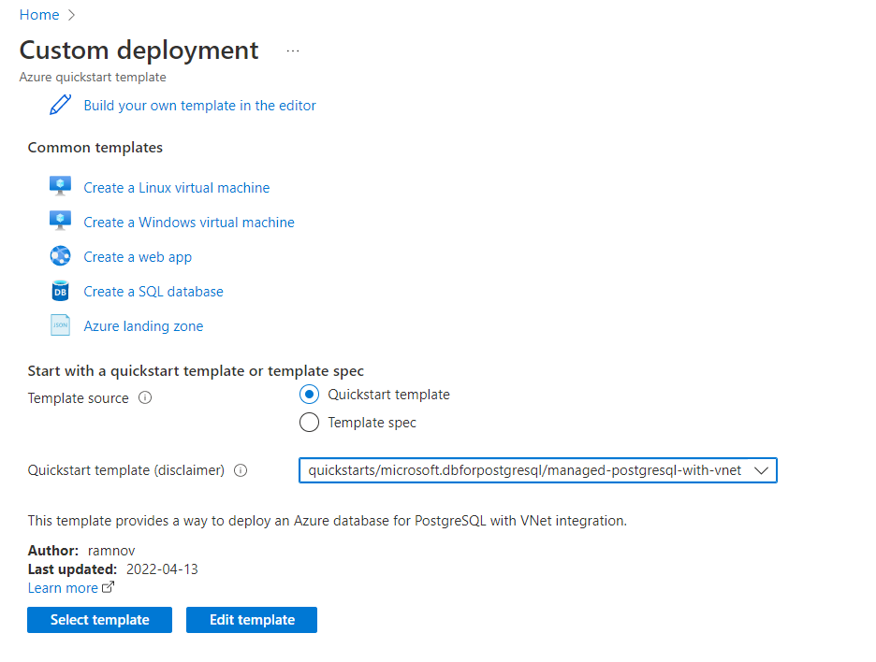

* **Provide resource group and server credentials**

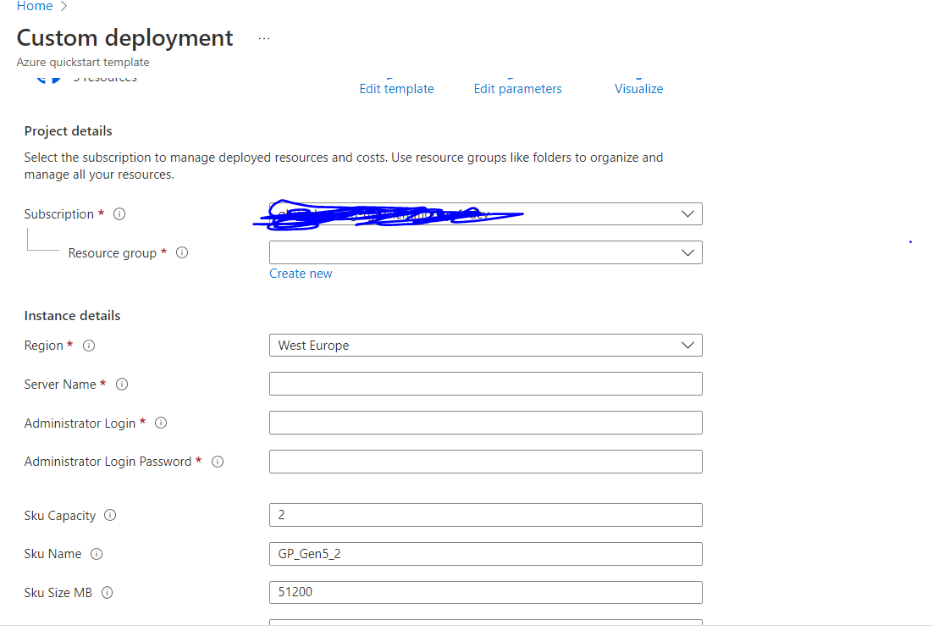

* **Click review +create . Resource will be created**

* **Connect to DB**

mysql -h testdemoserver1.mysql.database.azure.com -u myadmin@testdemoserver1

* **Firewall error will come .. note down the ip and open firewall**

az mysql server firewall-rule create --resource-group myresourcegroup --server testdemoserver1 --name AllowMyIP --start-ip-address 20.207.206.207 --end-ip-address 20.207.206.207

* **Connect to the server**

mysql -h testdemoserver1.mysql.database.azure.com -u myadmin@testdemoserver1 -p

* **Provide passsword**
* **Create Database**

CREATE DATABASE mysampledb;

USE mysampledb;

* **Create Table**

CREATE TABLE inventory (

-> id serial PRIMARY KEY,

-> name VARCHAR(50),

-> quantity INTEGER

-> );

* **Insert records to the Table**

Insert INTO inventory (id, name, quantity) VALUES (1, 'banana', 150);

insert INTO inventory (id, name, quantity) VALUES (2, 'apple', 200);

Select the records

* **select * from inventory;**

1. **Connect DB from VM**

* **Click on Azure CLI .Open Firewall for connecting VM from SQL**

az mysql server firewall-rule create --resource-group myresourcegroup --server testdemoserver1 --name AllowMyIP --start-ip-address 20.232.120.86 --end-ip-address 20.232.120.86

* **Connect to VM and install required softwares for DB connection**

ssh username@VM-ip

sudo apt-get update

sudo apt install mysql-client-core-5.7

* **Connect to the server**

mysql -h testdemoserver1.mysql.database.azure.com -u myadmin@testdemoserver1

-p

* **Provide passsword**
* **Select the records**

select * from inventory;

You will be able to see the records in the CLI

